W e d d i n g S t o r e
Measurement Guide

Dear Valued Customer, kindly requesting to take your measurements carefully as it is shows below in the guide and e-mail them back to care@patioucha.com in order to start tailoring your wedding dress.

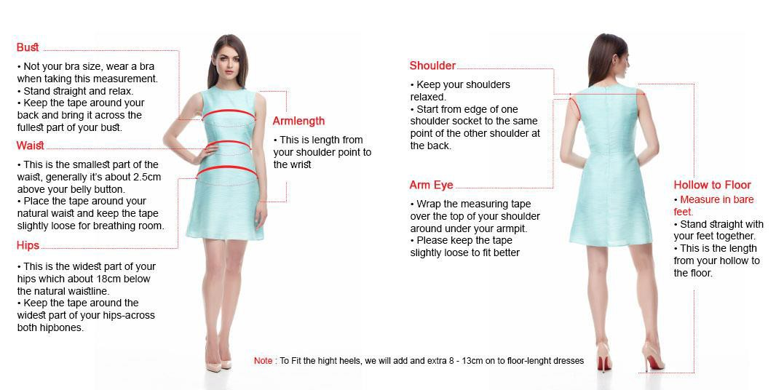Full Name : ….. Mobile Number : ….. Order Number : …..

Bust (cm) | Waist (cm) | Hips (cm) | Arm length (cm) | Shoulder (cm) | Arm Eye (cm) | Hollow to Floor (cm)

